**Exercise 2**

**1) Create a folder to store all your working files**

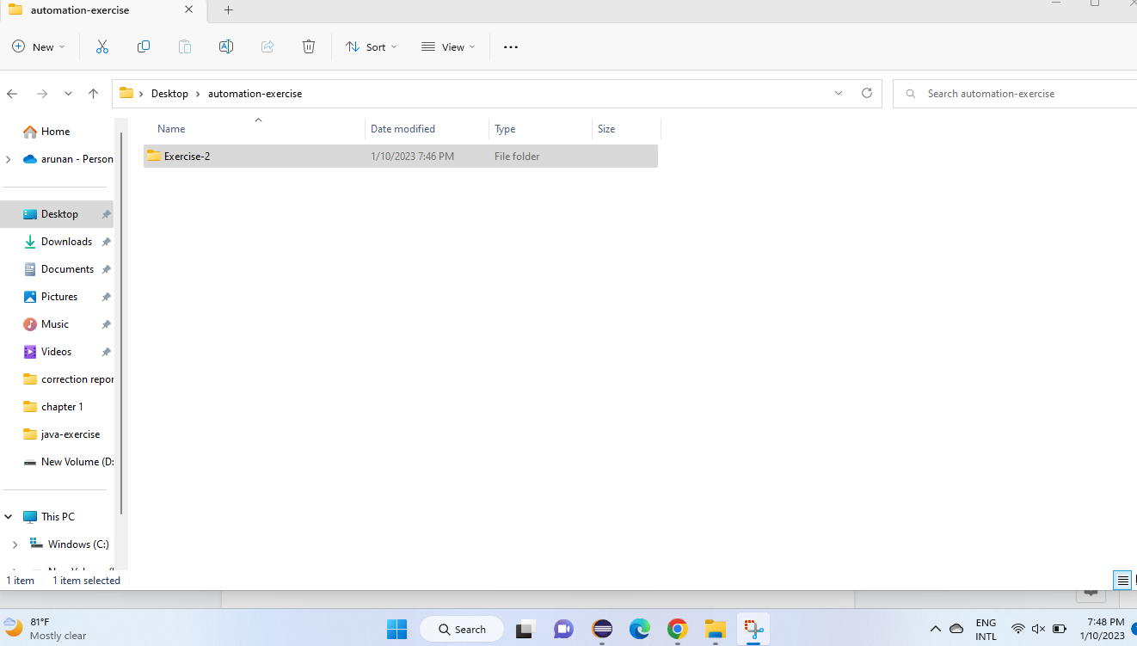

**2) Open notepad and type a simple java program to print ‘Hello world’ on the screen**

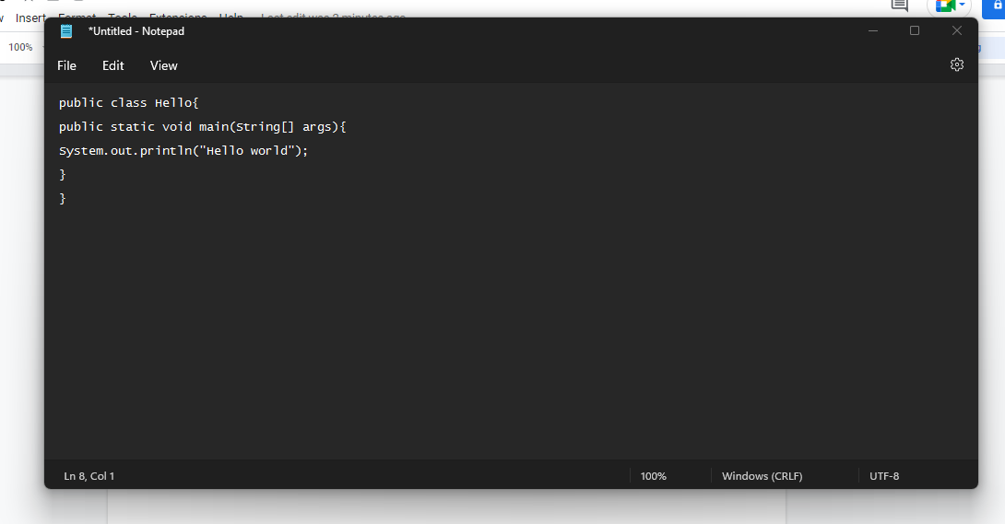

**3) Save the program as Hello.java under your working folder**

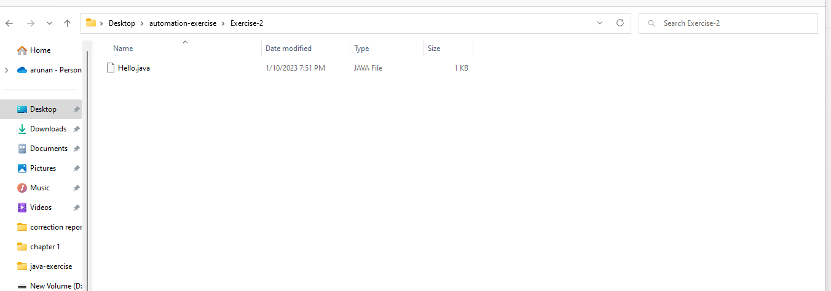

**4) Open command prompt and try to compile your program using javac**

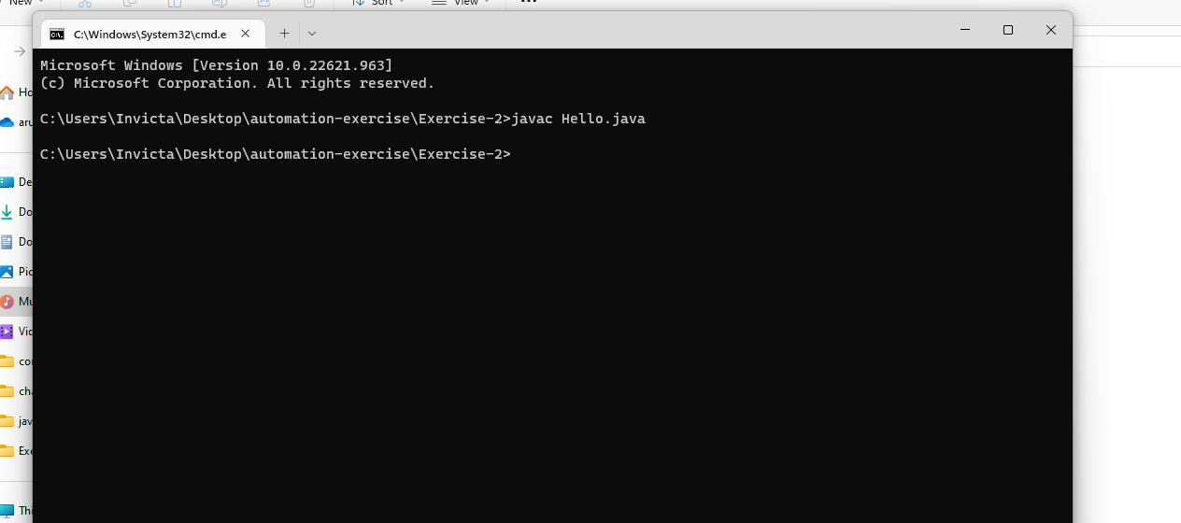

**5) Execute your program in the command prompt using the command java**

